Mendoza, Geraldine C.
Gilhang, Jhulia Reign
Santos, Janier Levine U. Serad, Sittie Aisah S.
C303
As we download the approved dataset, Student Depression & Lifestyle https://www.kaggle.com/datasets/aldinwhyudii/student-depression-and-lifestyle-100k-data?reso urce=download . We will begin the phase for Data Preparation and Data Cleaning using CLEAN Framework.
For the data cleaning and preparation, I decided to use XAMPP and MySQL Workbench instead of Power BI. At first, it really seemed like doing all the cleaning inside Power BI’s Power Query would be much easier since our team’s data modeling, dashboard, and visualization will have to be built there anyway. However, I chose to use a dedicated SQL database because it will give us a much better setup for our project pipeline. First, I wanted to separate our database backend (MySQL) from our visual frontend (Power BI), which is how actual data professionals organize their pipelines.Second, since our instructor strictly requires us to use the CLEAN framework and document our work to prove we did it ourselves, I knew that by writing out this explicitly SQL queries would give me a clear code log to show as solid proof of my independent work. Lastly, by cleaning all 100,000 rows directly in MySQL, I can make sure the dataset is already pristine before it ever touches Power BI. This saves a lot of computer memory, fixes any loading lag, and makes it way easier for my next group member to jump straight into the data modeling and build the Star Schema relationships without any extra hassle.
- We begin by opening the XAMPP, launching the XAMPP will allow us to find Apache and MySQL in the XAMPP Control Panel. Click the Start button (both for Apache and MySQL). Wait for a few minutes until their background turns green.
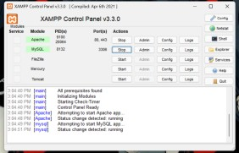
- Next thing we have to open now is the MySQL Workbench. Once it is launched, we should create a connection by clicking the + icon next to “MySQL connections” near the
top left.
  - We also set the connection name to: Student_Wellness_FProject
  - Hostname to: 127.0.0.1
  - Port to: 3306
  - Username to: root
  - And we will leave the password blank
- We click the OK button to save the connection.
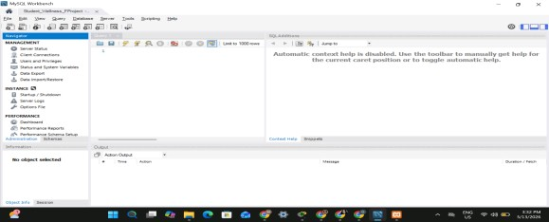
- Tadaaah! We’re in! If we want to remove the unnecessary or sidebar that we didn’t need, we could click the word View at the top and hover over Panels and click the Hide Secondary Sidebar
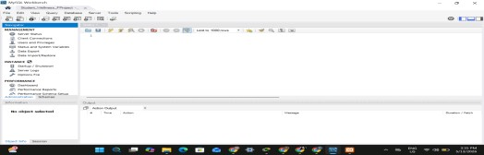
- We could click the icon SQL with a + if we want to create a new query (and that’s how we will do it). Now, we will create the environment so we could start the cleaning for our dataset. We start our data cleaning by creating and using the database we just created student_wellness_db and run it with the lightning bolt icon at the top (that means it will execute). Refresh it and we will see the student_wellness_db appear under the
Schemas tab. Right-click our student_wellness_db schema and select the Table Data Import Wizard.
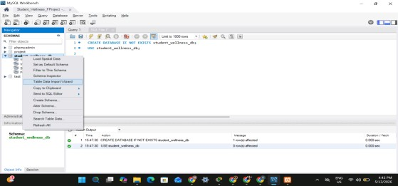
- We will browse the dataset from the source file that we acquired from Kaggle, click Open and then click the word Next > Next again > yes, Next again > hehe, Next again until we see that it's starting to import the data. Since, we have a huge dataset, as in huge (well its 100,000 records) it will take some time to load or to import our dataset.
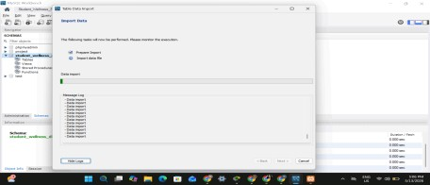
- Yehey! After waiting for so long, we have already imported the dataset that we need to clean. After that, we need to click (again) the refresh indicator near the word SCHEMAS for us to see the data we have imported under Tables.
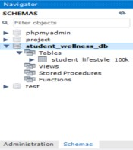
- Moving on, we will open a new query tab to start our data cleaning. We will begin with the execution of CLEAN Framework. We begin by C - Conceptualize. In this phase, we run a query to verify that our student_lifestyle_100k table contains exactly 100,000 records and that every Student_ID is distinct. This will establish our data boundaries and proves that no data was dropped or corrupted during the ingestion process.
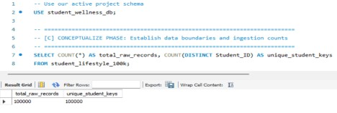
- Next, we move to L - Locate. In this step, we duplicate our new dataset into a secondary production table named student_wellness_cleaned so we do not overwrite our source data. We then run an update query to clean up categorical text columns like Department and Gender. By applying TRIM and casing functions, we will remove any hidden trailing spaces and standardize the text formatting so it does not break our downstream dashboard filters.
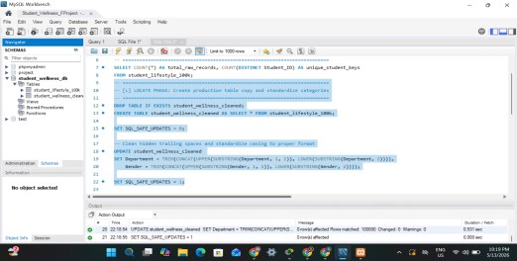
- We then proceed to E - Evaluate. We will perform a health audit on our numerical columns by querying the minimum and maximum boundaries for Age, CGPA, and Study Hours. This check validates that our continuous variables sit within logical real-world human limits (such as CGPA between 0.0 and 4.0) and confirms that the dataset contains no impossible structural outliers.
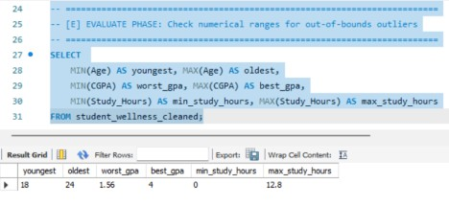
- Moving forward, we will then execute A - Augment to add analytical value to the dataset. As we can see in the picture below, I write an ALTER TABLE statement to append a new column called Work_Life_Balance to our database schema. We calculate this new metric by dividing a student’s Study_Hours by their Sleep_Duration, rounding it to two decimal places while using a defensive NULLIF clause to completely protect our pipeline against division-by-zero database errors.
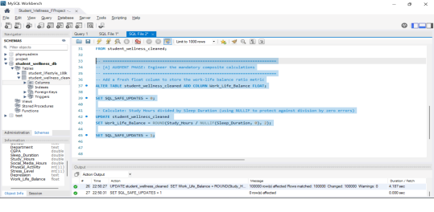
- Yehey! Finally, we complete our framework with N -Note. We execute a final SELECT query with a LIMIT
10 clause to run a quick quality assurance look over newly generated data layers. This final inspection ensures our transformations are executed properly and creates an audit trail, verifying that the data is structured, pristine, and ready for our member who will handle the Data Modeling to import into Power BI.
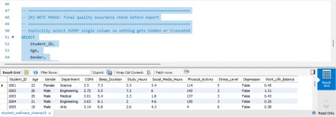
- After running our final quality check, we look at the Result Grid at the buttom of the screen. We need to verify that our newly calculated Work_Life_Balance column displays perfectly next to the other attributes for all of our 100,000 clean data entries.
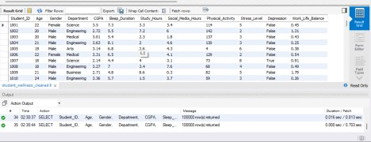
- Once everything looks good, we can finally export the dataset! Yey. To do this, we look right above the data results grid pane and click the Export button (a small icon that looks like a little spreadsheet grid with a blue arrow pointing outward).
- A window will pop up asking where we want to save it. We will set the format dropdown menu to CSV, name our final output exactly student_wellness_cleaned.csv , and save it straight to our desktop.
- Yehey! My job as the Data Preparation and Data Cleaning Lead is now officially done. All that is left to do is open our group chat, upload this to my members, and share our documentation so the next member can jump straight into power BI for the Data Modeling Phase.

Modeling Phase

After completing the Data Preparation and Data Cleaning phase, the cleaned dataset student_wellness_cleaned.csv was exported from MySQL and prepared for modeling. The next stage of the project focuses on Data Modeling, where the cleaned flat dataset is transformed into a structured Star Schema using Microsoft Power BI.

The primary objective of this phase is to organize the dataset into logical tables consisting of one Fact Table and several Dimension Tables. This structure improves data organization, enhances performance, and allows efficient dashboard creation and analytical reporting within Power BI.

Using Power Query Editor, the dataset was divided into the following tables:

- student_wellness_cleaned – Source reference table
- fact_student_wellness – Central fact table
- student_dim – Student demographic dimension
- department_dim – Department lookup dimension
- behavior_dim – Student behavior dimension

The following sections describe the step-by-step process used to construct the data model.

Step 1: Loading the Cleaned CSV into Power BI
The process begins by opening Power BI Desktop and importing the cleaned dataset. From the Home, Get Data, Text/CSV is selected, and the file student_wellness_cleaned.csv is loaded into Power Query Editor.

Upon loading, all dataset columns become visible, including the engineered Work_Life_Balance column created during the CLEAN Framework phase. This imported table serves as the base reference query, which is used to generate all succeeding dimension and fact tables without modifying the original data.

The successful loading confirms that column headers, data types, and records were correctly preserved from the MySQL export.
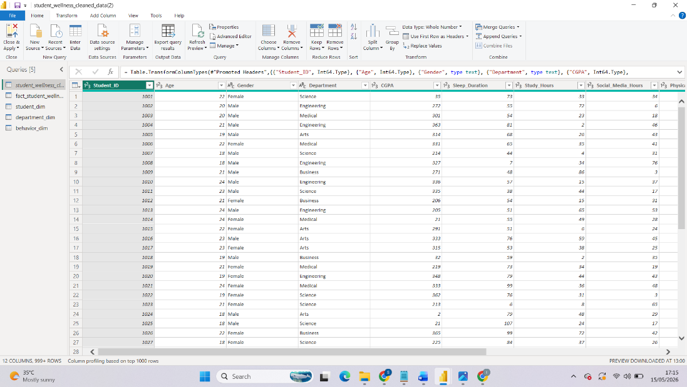

Step 2: Creating the fact_student_wellness Table
The central component of the Star Schema is the fact_student_wellness table.
A final reference query was created from the original dataset, retaining only analytical measures and foreign keys:

- Student_ID
- dept_id
- behavior_id
- CGPA
- Stress_Level
- Work_Life_Balance
- Depression

The dept_id and behavior_id fields act as foreign keys linking the fact table to their respective dimension tables. Proper data types were verified to ensure compatibility with Power BI relationships.
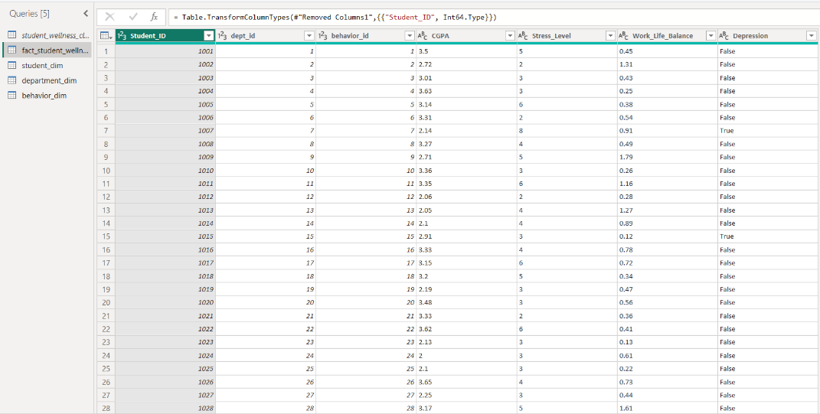
This table contains measurable data used for analysis and visualization.

Step 3: Creating the student_dim Table
The first dimension table created is student_dim, which stores student demographic information.
A reference query was created from the original dataset to avoid duplicating data. The query was renamed student_dim, and only relevant attributes were retained:

- Student_ID
- Age
- Gender
- Physical_Activity

All unnecessary columns were removed using Remove Other Columns. Duplicate records were eliminated based on Student_ID to ensure each student appears only once. This step guarantees that the table functions properly as a dimension table containing unique entities.
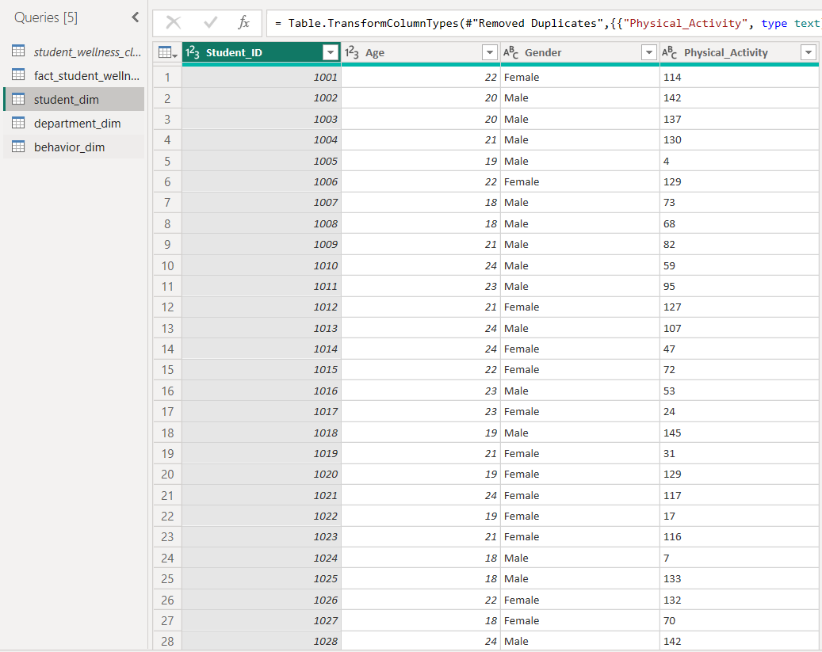

Step 4: Creating the department_dim Table
Next, the department_dim table was constructed to serve as a lookup table for academic departments.

A reference to the original dataset was again created and renamed department_dim. Only the Department column was retained. An Index Column was added and renamed dept_id, which acts as the primary key.

Duplicate department values were removed to ensure a clean and unique list of departments. This table provides standardized department identifiers that will later connect to the fact table.
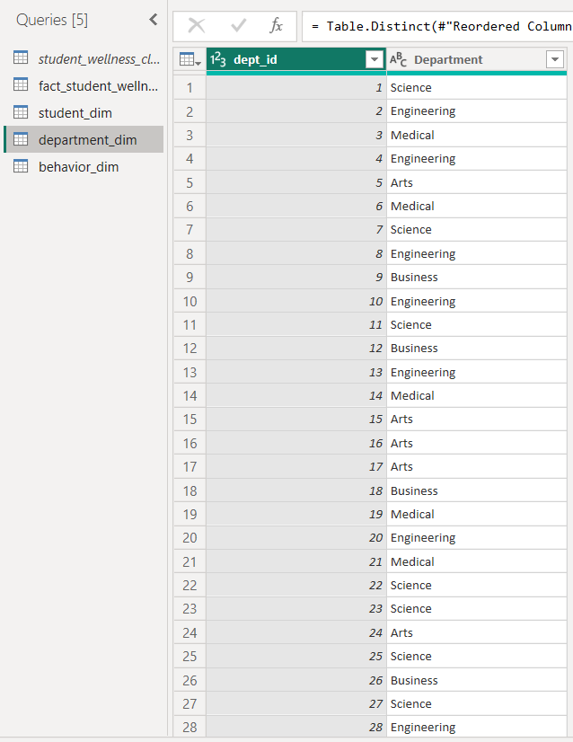

Step 5: Creating the behavior_dim Table
The behavior_dim table represents student lifestyle and behavioral characteristics.
From another reference query, only the following columns were retained:

- Sleep_Duration
- Study_Hours
- Social_Media_Hours

An Index Column was added and renamed behavior_id to serve as the table’s primary key. Duplicate behavioral records were removed to ensure each behavior profile is uniquely represented.
This dimension enables detailed behavioral analysis while preventing redundancy within the main dataset.
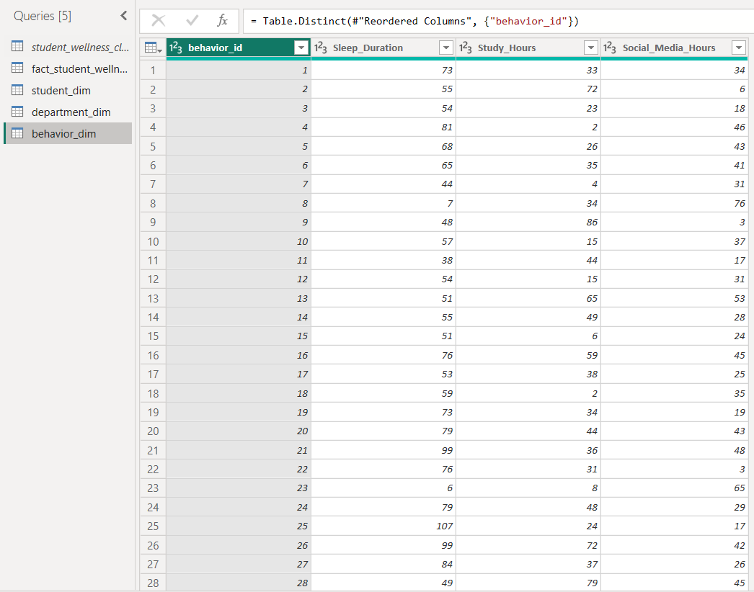

Step 6: Building Star Schema Relationships in Model View

After completing all transformations, the queries were applied and loaded into Power BI. The Model View was then used to establish relationships between tables.

The following relationships were created:

- fact_student_wellness.Student_ID → student_dim.Student_ID (Many-to-One)
- fact_student_wellness.dept_id → department_dim.dept_id (Many-to-One)
- fact_student_wellness.behavior_id → behavior_dim.behavior_id (Many-to-One)

Each relationship follows the standard Star Schema design, where the fact table resides at the center and dimension tables surround it. This structure supports efficient filtering, slicing, and aggregation during dashboard analysis.
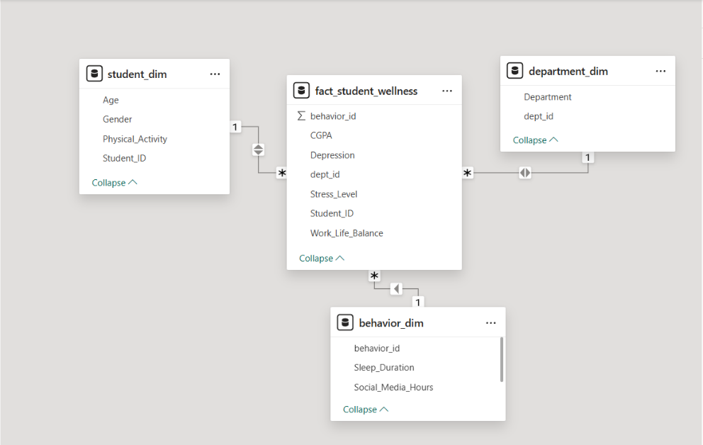

Summary

The Data Modeling phase successfully transformed the flat student_wellness_cleaned.csv dataset into a structured Star Schema within Power BI. The model now consists of one fact table connected to three dimension tables through properly defined relationships.

By organizing the dataset into normalized tables, the model improves performance, ensures data consistency, and prepares the project for the Dashboard and Data Visualization Phase. With this foundation completed, the next project member can proceed directly to creating interactive reports and analytical dashboards.

Visualization

After the Data Preparation and Data Cleaning phase using the CLEAN Framework and the completion of the Data Modeling phase through the implementation of a Star Schema model in Power BI, we now proceed to the final phase of the project which is the Data Visualization and Dashboard Development Phase. In this stage, the cleaned and structured dataset is transformed into a fully interactive analytical dashboard capable of presenting meaningful insights regarding student wellness, stress levels, depression indicators, sleep behavior, and academic performance’

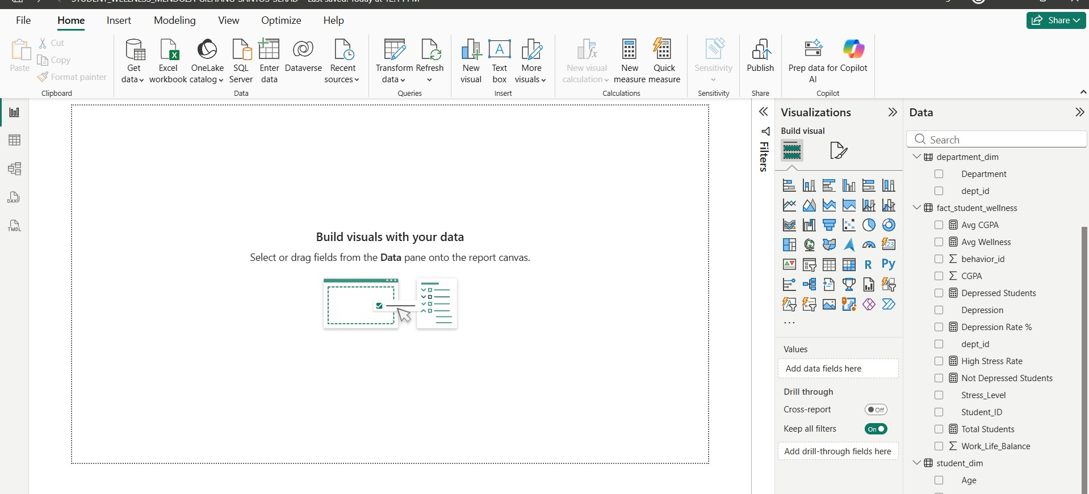

We first design the overall dashboard layout by creating a wellness-themed interface using a dark green and gold color palette. We also insert a title text box labeled:

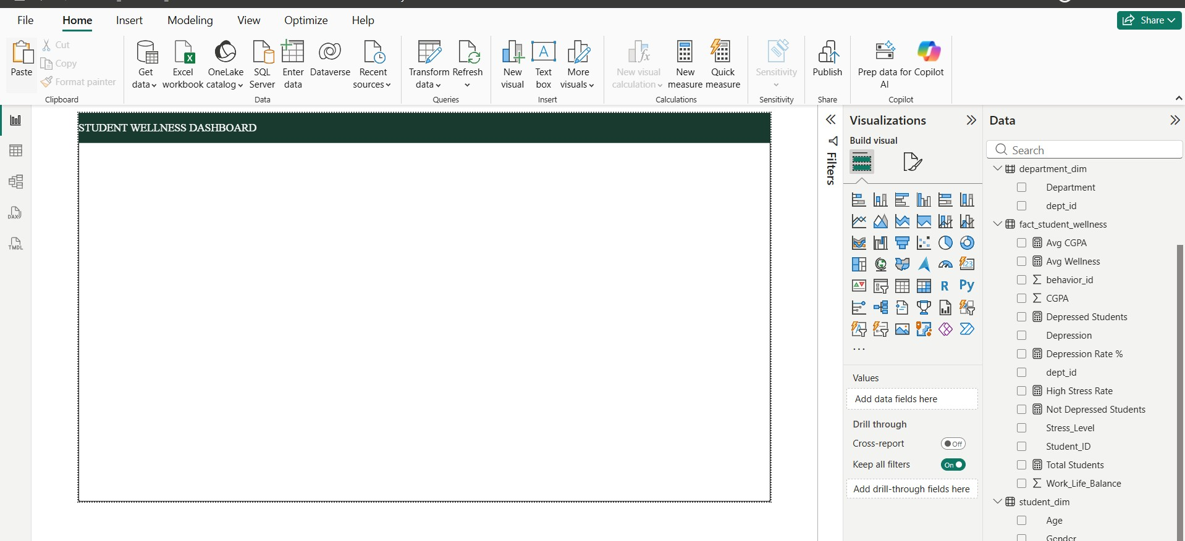

This title serves as the main header of the visualization system and establishes the dashboard’s analytical theme.
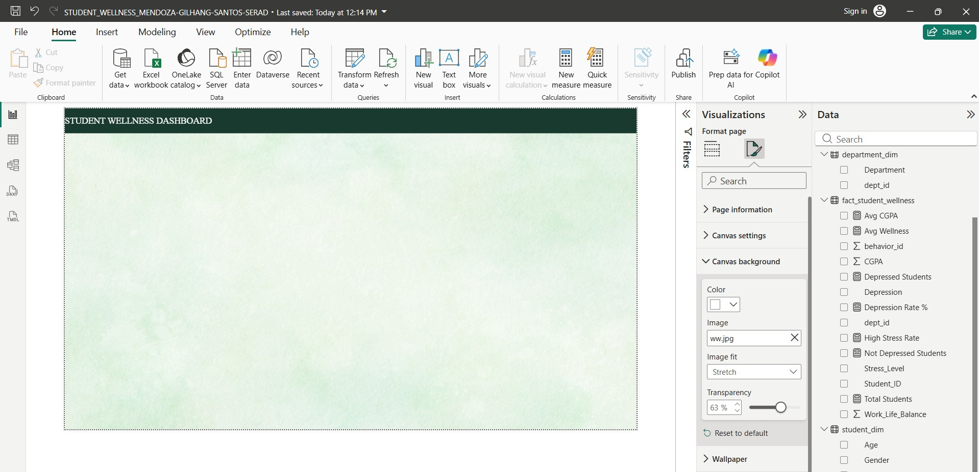

Next, we create KPI Cards positioned horizontally at the top section of the dashboard to summarize the most important wellness metrics instantly. These cards provide users with a quick overview of the dataset’s core indicators without requiring additional interaction.

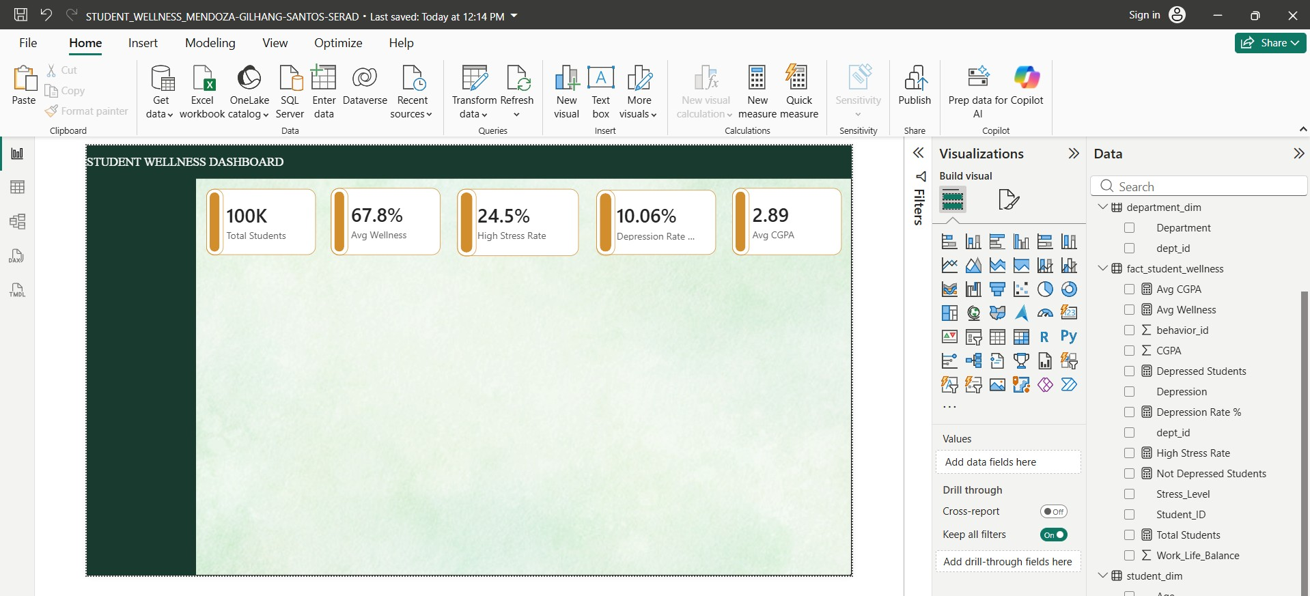

We also apply percentage formatting and proper decimal formatting to ensure the values are readable and professionally presented.

After setting up the KPI cards, we create our first analytical visualization titled:

For this visual, we use a Line and Clustered Column Chart to compare sleep duration counts alongside stress rate patterns across different departments. This visualization helps identify departments that may exhibit heavier wellness pressure or unhealthy sleep behaviors

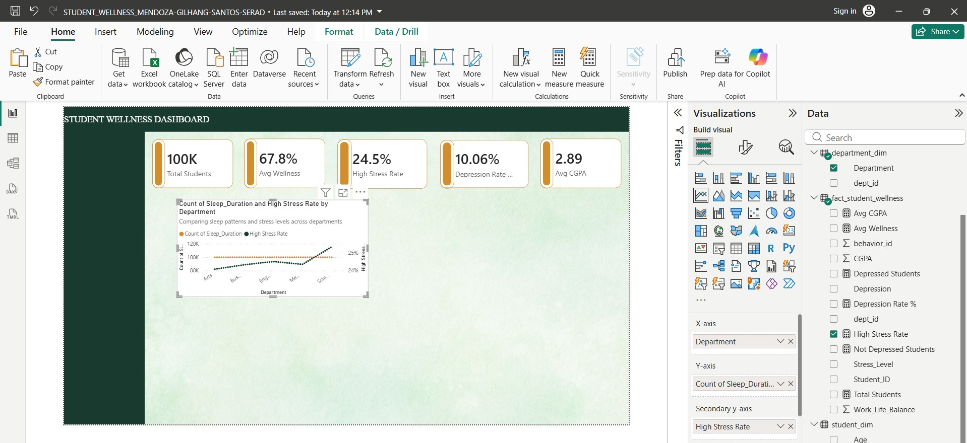
We also add a subtitle to improve readability and explain the purpose of the chart:

This chart analyzes the relationship between students’ average sleep duration and academic performance (CGPA) while grouping the data points according to academic departments. Each colored bubble represents a department category, allowing viewers to identify patterns or correlations between sleep habits and educational performance.

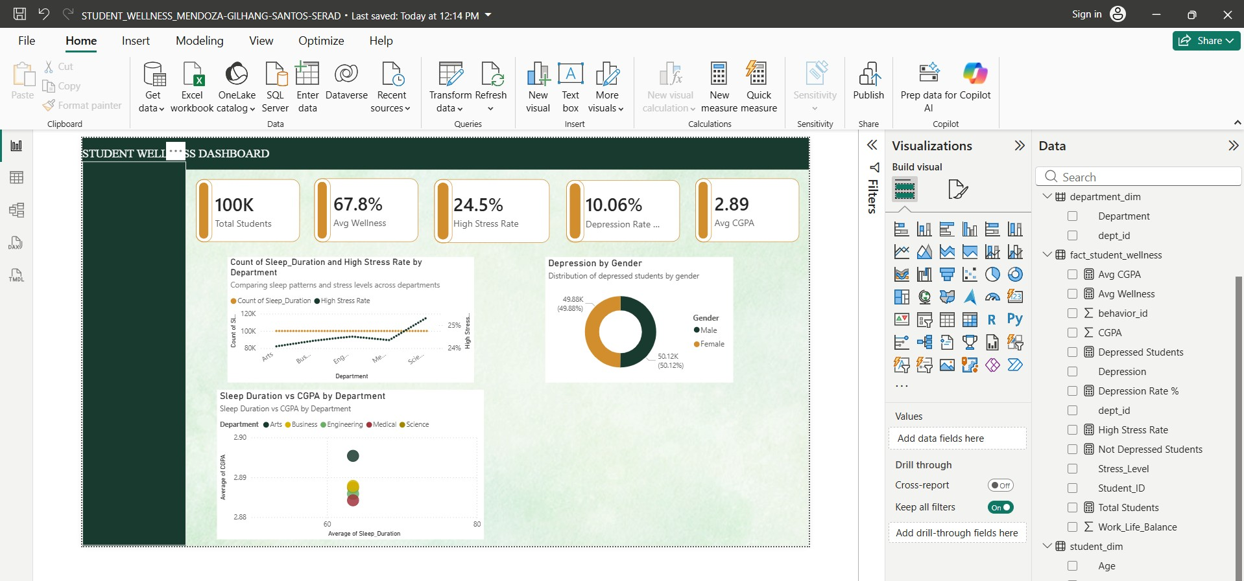

We then proceed to build a Donut Chart titled:
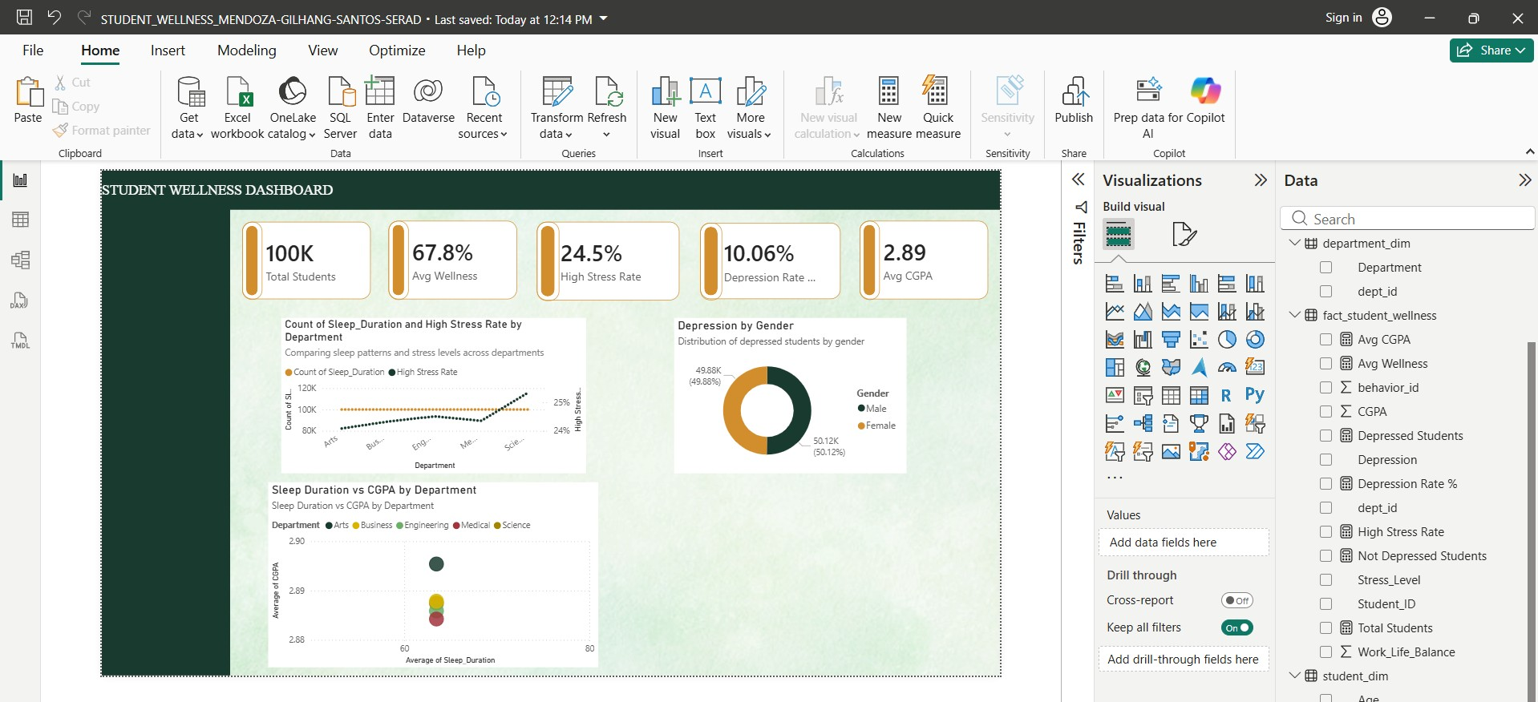

This visualization displays the proportion of depressed students categorized by gender. Using this chart, users can quickly analyze the distribution of depression prevalence between male and female students.

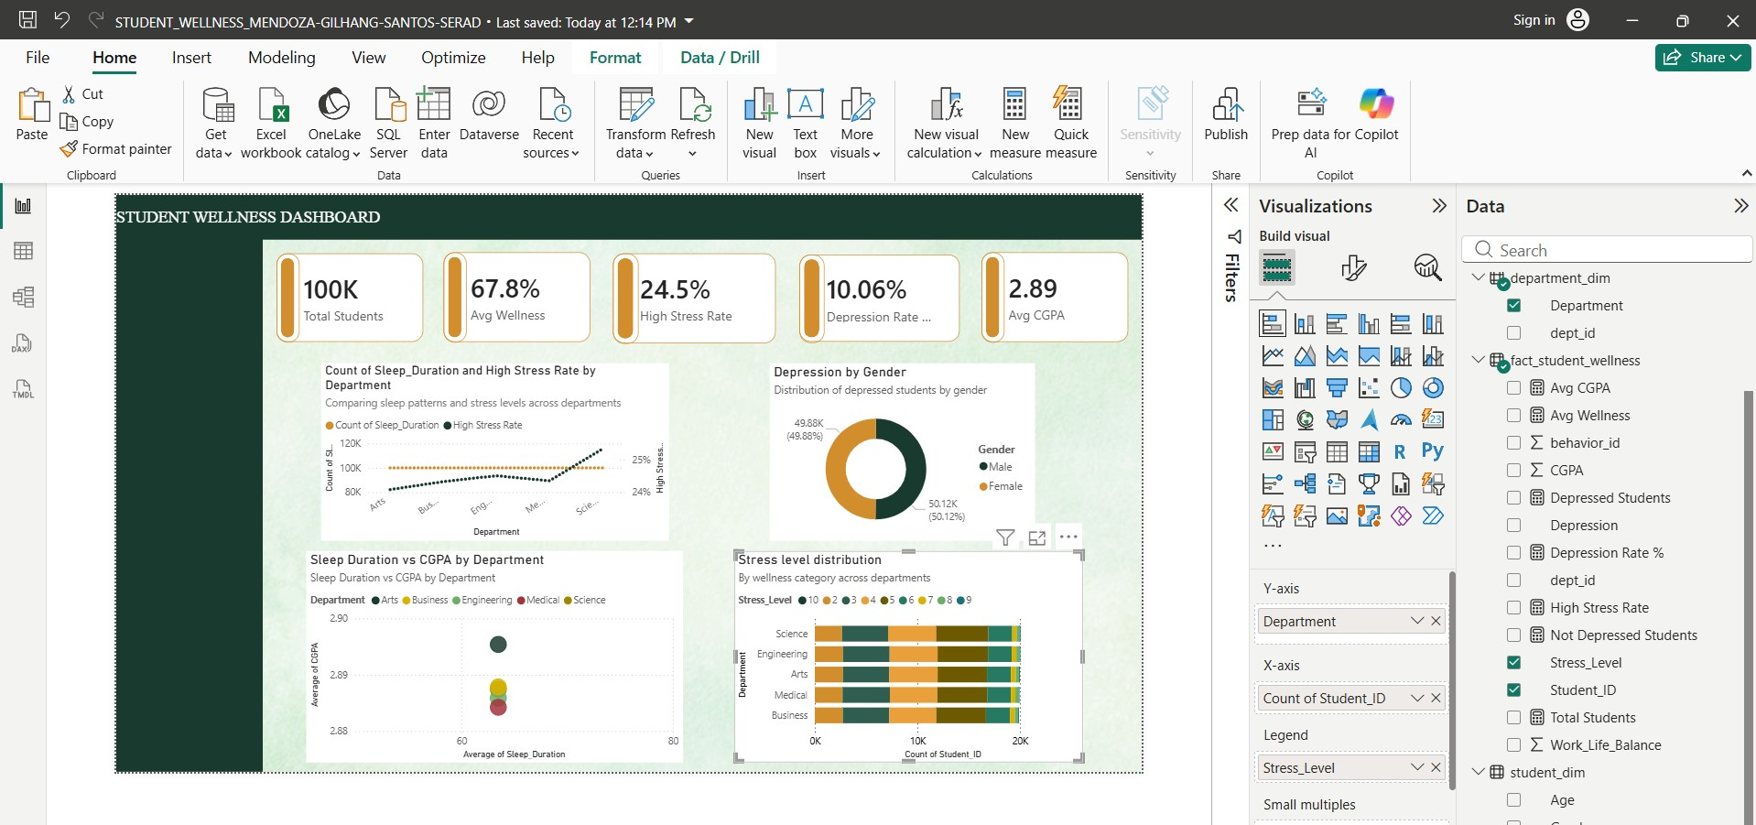

This visualization displays the distribution of stress levels among different academic departments. By using stacked categories, users can compare stress concentration patterns between departments and identify which groups may experience greater wellness challenges.

To improve dashboard interactivity and user-driven analysis, we add slicers positioned vertically on the left side of the dashboard. These slicers allow users to dynamically filter all visuals simultaneously based on selected demographic and wellness categories.

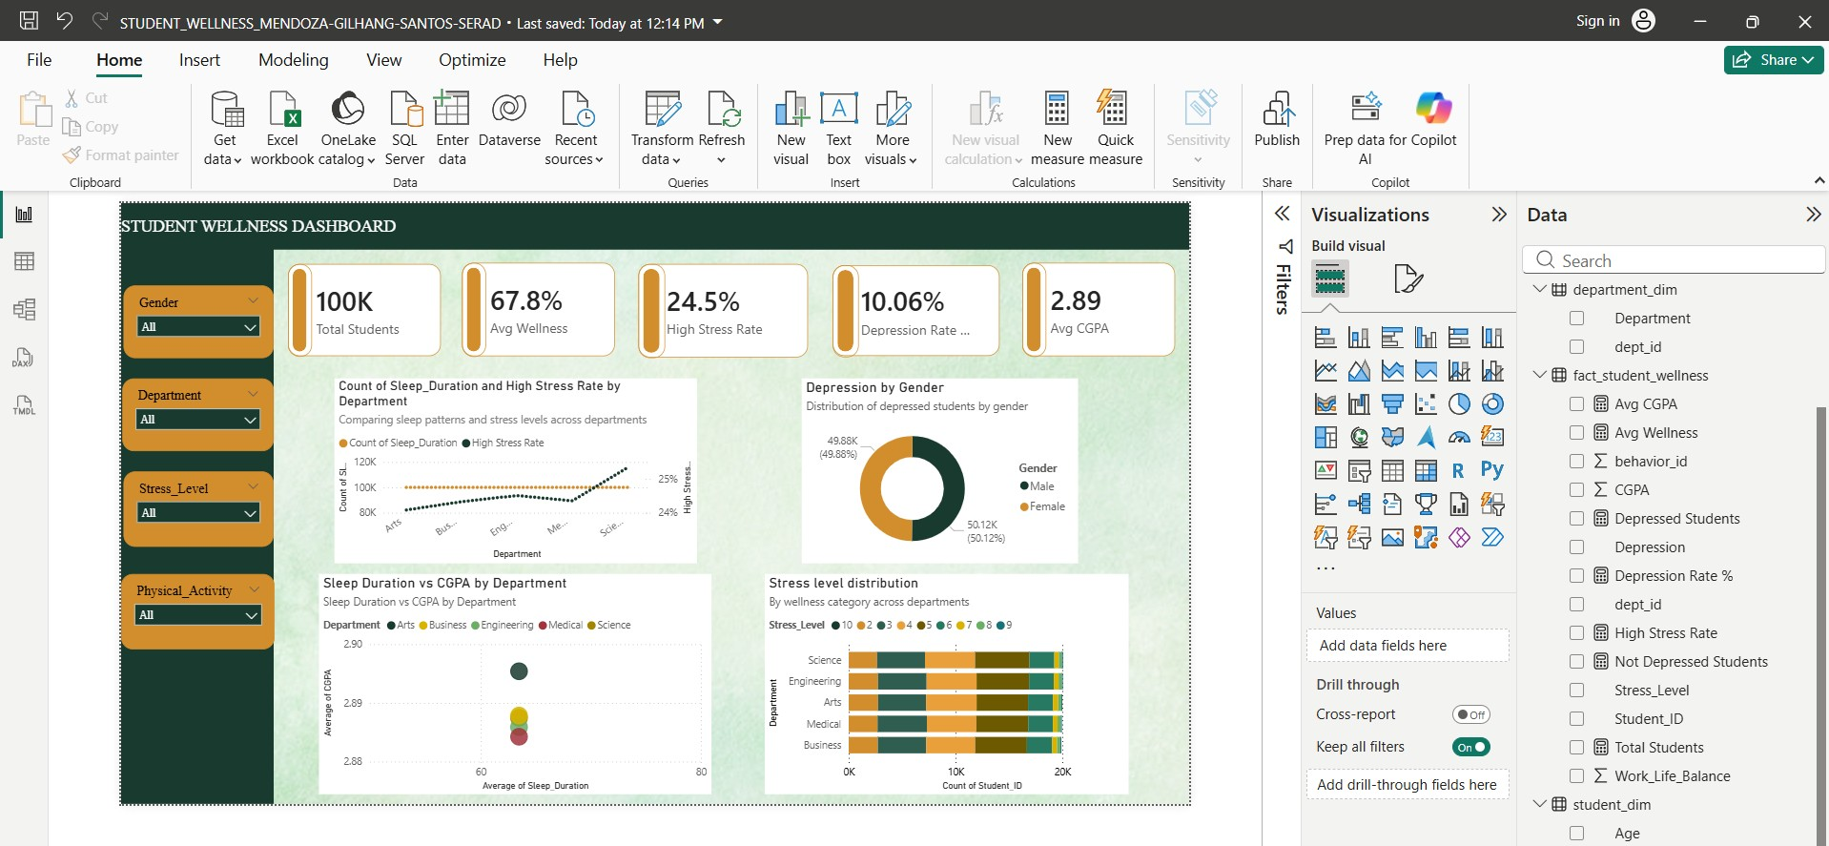

These interactive filters help users perform more focused exploratory analysis depending on their selected conditions.

After all visuals are completed, we perform final formatting adjustments such as:

- Aligning visuals consistently
- Adjusting font sizes and spacing
- Applying visual borders and rounded corners
- Ensuring chart titles and subtitles are readable
- Standardizing color consistency across all visuals

Finally, after validating that all visuals, slicers, measures, and relationships function correctly, we save the final Power BI project file as:
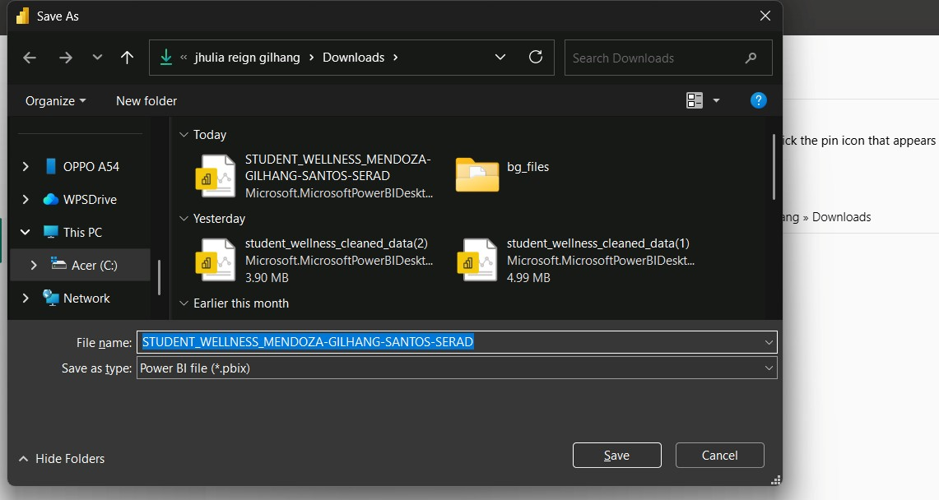

The dashboard is now fully interactive and capable of presenting analytical insights regarding:

- student wellness balance,
- depression prevalence,
- stress distribution,
- sleep behavior,
- and academic performance.

This concludes the Data Visualization and Dashboard Development phase of our Student Wellness Analytics Project.

